User Manual

Online Reservation System King Mongkut Institute of Technology Ladkrabang

This User Manual is a part of subject

Information System and Analysis (060xxxxx)

Table of Contents

Searching for rooms availability 3

Step 1 Search for available Space 3

Step 2 Modifying search preference 4

Step 3 View space information and notices 4

# Searching for rooms availability

This is the first step for you to reserve a room with us. All of the functions will be opened to everyone to search for your perfect space. But in order to reserve that space, signing in to the service is required.

## Step 1 Search for available Space

In the landing page, type in a name of the space that you want to reserve. If you don’t have any space preferences or want to choose a space based on Faculty building, room name or number of seats, click advance to reveal more options.

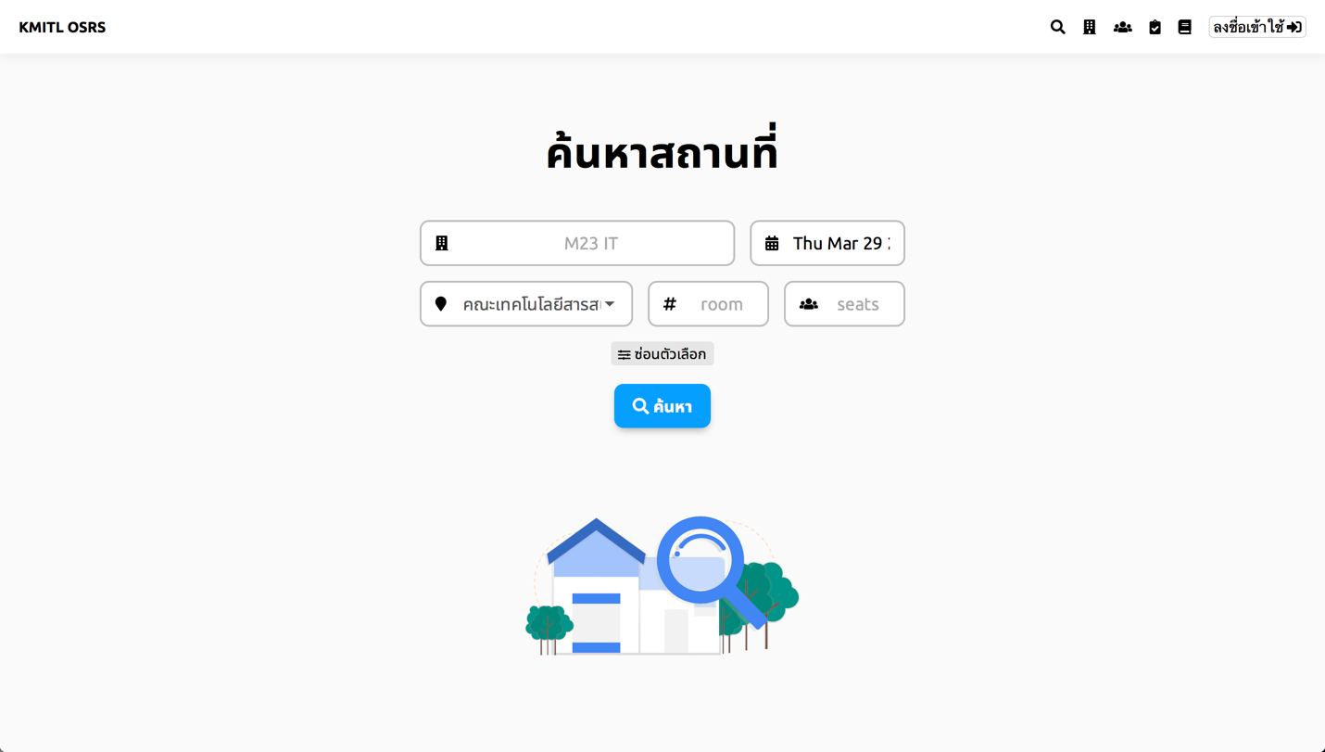

Figure 1 Interface with Advanced Settings on

Note : you need to enter 1 of the 5 filter in order to continue. You may add more filters afterward.

After filling the filter, click “Search” button to continue.

## Step 2 Modifying search preference

Result that match your filter will come up. You may click at the card to see more information about the room, or to reserve this room.

Note : You may change your filter (adding, modifying and remove your filter) at any time. You will need to click Search to confirm your new search filter.

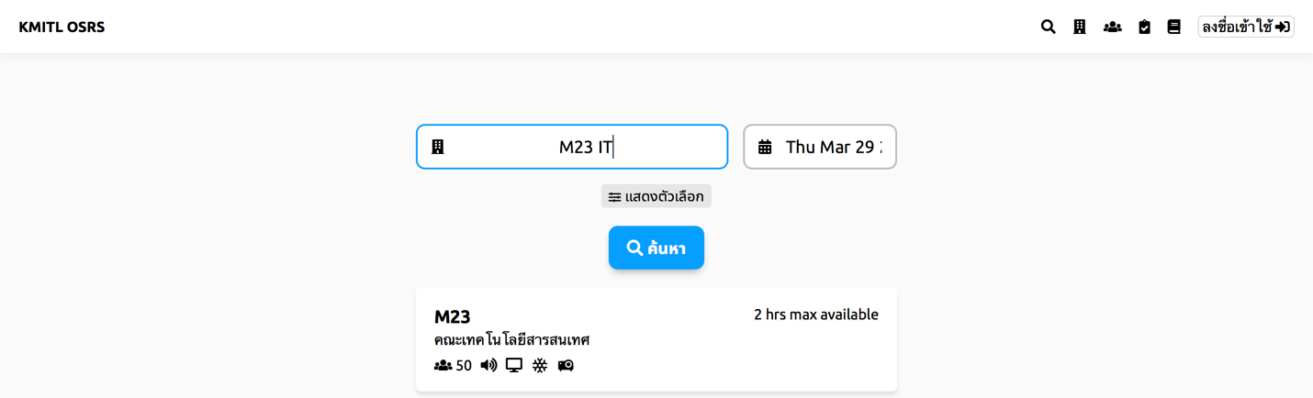

Figure 2 After clicking Search, the result of the available room will come up

## Step 3 View space information and notices

By clicking the result card, it will leads to a space information page. It gives user a freedom to see information like audio equipment, computer equipment, type of space, available seats (for space that is room and conference room) and many other information. User with administration permission can add more information about the space at anytime.

At the bottom of the page, you can start reservate that space. Time that is count as available will be marked in Green. User can click or swipe the time you want to reserve and click the calendar to change a date of reservation.

Clicking continue will continue the reservation process with time, date, space as you select. Signing in is required in order to continue the process.

## Step 4 Enter reservation additional fields

Most of the reservation needs more than a date, time and space. Reservation needs a reasons to reserve. This will directly given to authorities and approver for evaluating user request.

Some space will require more information about user (eg. Phone Number, Student ID, E-Mail Address). These personal information will be automatically filled up using your information. ;All of these information will be stored as a logging process.

By filling up the reservation form and clicking continue, user can cancel the request **at anytime prior to reservation time** and accepts faculty or/and university terms and conditions.

## Step 5 Use the room

After your reservation ticket is approved, you are free to use the room. There is no steps after that.

You will get a notification in inbox of a confirmation ticket. That ticket is used for authentication with faculty administrator, security guards, maid. Printed version of that ticket is preferable.

Note : If you like to cancel a reservation, you might need to contact faculty administration for emergency cancellation. (Please see our reservation cancellation policy for more information)

# Checking reservation status